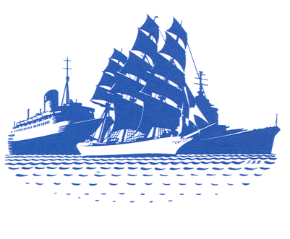

WORLD SHIP SOCIETY

APPLICATION FOR A TRAVEL BURSARY TO ATTEND THE BCMH NEW RESEARCHERS CONFERENCE
8-9th April 2022 at Chatham Historic Dockyard.

Ph.D students and independent researchers studying maritime topics are invited to apply to the World Ship Society for assistance with the costs associated with attendance at this conference. It is expected that most applicants will be presenting papers but those just wishing to attend will also be considered. Successful applicants will be awarded £100 towards their travel and/or accommodation costs.

SECTION A to be completed by all applicants

Your name

Current address

How long have you been involved in maritime history research?

Less than five years
More than five years

If you are an employee please provide the name of your organisation/museum and your position in it.

Your brief biography (250 words maximum):

Are you presenting a paper?

If yes, please give the title of your paper:

Please attach a copy of your abstract which, for successful applicants and in its final form, should contain the following statement:

Acknowledgement: “xyz” (your initials) is the recipient of a travel bursary from the World Ship Society

SECTION B to be completed by students

University/College:

Research topic:

Supervisor:

SECTION C to be completed by independent scholars or those working for a specific organisation such as a museum

Research topic:

Do you undertake research on behalf of an organisation or as an independent scholar?

Independent:
Employee:
Other:

Please submit your completed application form as an e-mail attachment to Dr Roy Fenton at roy@rfenton.co.uk or by post to 18 Durrington Avenue, London SW20 8NT

The closing date for applications is 1st April 2022

