

**New Researchers in Maritime History Conference**

McCance 301, University of Strathclyde, 22-23 March 2024

The British Commission for Maritime History (BCMH), in association with the University of Strathclyde, is delighted to welcome you to for the twenty-ninth conference for new researchers. This annual conference organised by BCMH is supported by the Society for Nautical Research.

Registration link: <https://forms.gle/KEAa12CKDBFfdraB7>

Note that prior to the conference, a link will be sent to all registered participants to pay the required registration fee (£30 student / £35 non-student/ Speakers, Keynote & Prize winners £0).

**Friday, 22 March 2024**

**15:00 – 16:00:** **‘Meet the Curator’ session and viewing of ‘Glasgow: City of Empire’ exhibition** **with Nelson Cummins, Curator of Legacies of Slavery and Empire**. Meet at the Centre Hall Reception Desk, [Kelvingrove Art Gallery & Museum](https://www.glasgowlife.org.uk/museums/venues/kelvingrove-art-gallery-and-museum).

**17:00 – 17:45: Registration and reception**, McCance 301, University of Strathclyde

**17:45: Welcome, Dr Helen Doe,** Chair, British Commission for Maritime History

**18.00: Keynote Lecture: Prof Alison Cathcart**, Professor of Early Modern Scottish and Archipelagic History at the University of Stirling, “The ‘scattered isles in the polar ocean’: Scotland and the sea in the (long) sixteenth century.”

**20.15: Conference Dinner (optional) at Amore Ristorante e Pizzeria**, 30 Ingram Street, Merchant City, Glasgow, G1 1EZ (2 course set menu at £24.95pp).

**Saturday, 23 March 2023**

**8:00 – 9:00: Registration**

**9:00: Conference Coordinator’s Welcome, Dr James Davey/Dr David Wilson**

**9:15 – 10:45 Session One: ROUTES AND RESOURCES**

**Robert MacLean** (University of Glasgow Archives & Special Collections), ‘The Glasgow Soaperie Company’s role in Mediterranean and Atlantic Trade’.

**Sabrina Fröhlich & Kamil Muratov** (Helmut-Schmidt University/ University of the Federal Armed Forces, Hamburg), ‘No wood, no ships’: The Royal Navy's Timber Problem from a Diplomatic and Craftsmanship Perspective

**Guy Collender** (University of Portsmouth), ‘From a ditch to a global waterway: How the metamorphosis of the Clyde influenced port development from London to Manchester and Chicago to Calcutta'.

**10.45 – 11.15 Coffee**

**11.15 – 12.45 Session Two: WOMEN AND THE SEA**

**Hannah Gibbons** (University of Exeter), ‘Maritime Matriarchs: women, credit, goods and services in the dockland communities of eighteenth-century London’.

**Grace McNutt**, (Dalhousie University), ‘The Failure of Victorian Domesticity? Emily J. Spicer and the Making of Home at Sea, in Port, and on Shore, 1888-89’.

**Zara Money** (University of Portsmouth), ‘In service of the sea: Women’s maritime roles in late-nineteenth to early-twentieth century Britain’.

**12.45 – 13:30 Lunch**

**13:30 Presentation of awards**

**13.45 – 14.45 Session Four ENCOUNTERS AT SEA**

**Laura Birkinshaw** (University of Hull), ‘Disease transmission and inhibition during the transatlantic slave trade’.

**Alexandra Ward** (University of Leeds), ‘Living in “Constant and Immediate Proximity to the Dead”: “Liberated African” Health On Board Emigration Vessels, 1840 – 1872’.

**14.45 – 15.15 Coffee**

**15:15 – 16.15 Session Three: THE SEA AND IDENTITY**

**Muskaan Gandhi** (National Museum of the Royal Navy, Hartlepool), ‘HMS Trincomalee: Encounters with the First Nations People of the Pacific’.

**Jane Stewart** (The Courtauld Institute, University of London), ‘Elizabethan Sea Burial: the Monument to Sir James Hales in Canterbury Cathedral’

**16.15: Closing remarks**

**INFORMATION FOR DELEGATES**

**CONFERENCE LOCATION**

The Conference will be held in the McCance Building, Room MC 301. The McCance Building is entered via Richmond Street (see map below). There will be signs directing you to the room upon entering.

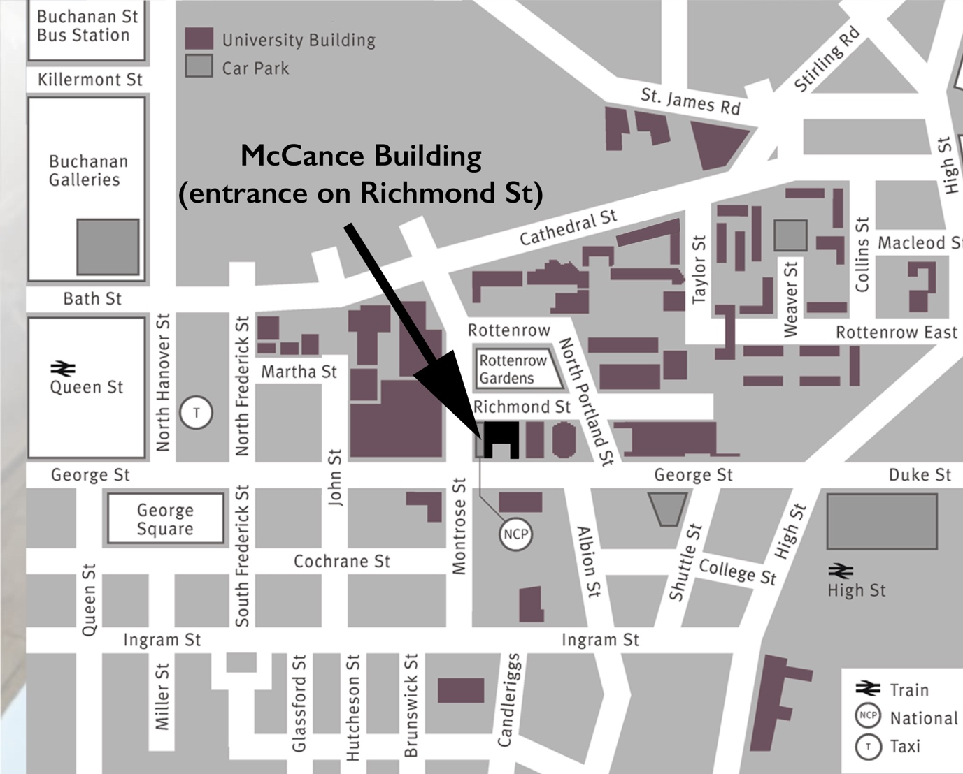

[Click here to see an interactive map of the University of Strathclyde and McCance Building](https://www.strath.ac.uk/maps/?building=mccancebuilding)

**VISITING AND STAYING IN GLASGOW**

The University of Strathclyde is situated in Glasgow City Centre, near George Square and the Merchant City.

Information on Glasgow City Centre and the Merchant City area can be found here:

<https://peoplemakeglasgow.com/neighbourhoods/city-centre/>

<https://peoplemakeglasgow.com/neighbourhoods/city-centre/merchant-city>

**ACCOMODATION**

There are a number of hotels in the Merchant City and the university is a short walk from most City Centre locations.

These hotels are particularly well-placed and usually offer reasonable rates:

**Premier Inn Glasgow City Centre (George Square) hotel**

187 George Street, Glasgow,

G1 1YU

<http://www.premierinn.com/gb/en/hotels/scotland/strathclyde/glasgow/glasgow-city-centre-george-square.html>

**The Merchant City Inn**

52 Virginia St

City Centre

Glasgow

G1 1TY

[http://www.merchantcityinn.com](http://www.merchantcityinn.com/)

**Mercure Glasgow City Hotel**

201 Ingram Street

Glasgow

G1 1DQ

<https://www.mercureglasgow.co.uk/>

There are a number of other hotels available in the nearby vicinity:

<https://peoplemakeglasgow.com/findahotel>

Another option is AirBnB with a number of rooms available near the university. Search ‘Glasgow Merchant City’: [www.airbnb.com](http://www.airbnb.com/)

**CITY INFORMATION**

You can use the following link for information on Glasgow including how to get here, accommodation, and things to do: <https://peoplemakeglasgow.com/visiting>

Tours: <https://peoplemakeglasgow.com/things-to-do/tours>

What’s On: <https://peoplemakeglasgow.com/whats-on>

Delegate Offers (including discounts for airport transfers): <https://glasgowconventionbureau.com/plan-your-meeting/meeting-planners-toolkit/delegate-offers/>

There’s also more information and resources available here: <https://glasgowconventionbureau.com/plan-your-meeting/meeting-planners-toolkit/>

**QUESTIONS**

If you have any questions about visiting and staying in Glasgow then please do not hesitate to contact David Wilson on [david.wilson.101@strath.ac.uk](mailto:david.wilson.101@strath.ac.uk)