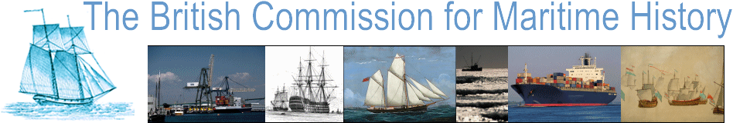

New Researchers in Maritime History Conference 2023

University of Portsmouth, 31 March – 1 April 2023

**Call for Papers**



The British Commission for Maritime History (BCMH) invites contributions to its twenty-eighth conference for new researchers. This year it will be held at the University of Portsmouth, one of Britain’s leading centres for naval and maritime history, with the Historic Dockyard on its doorstep. This is an ideal location in which to hold this annual conference and provides a unique opportunity for new scholars to present their work in a historic setting.

The Conference, which is supported by the Society for Nautical Research, helps emerging scholars who wish to share their work in a supportive environment and build relations with other maritime historians. We encourage applications from postgraduate students and warmly encourage participation by independent scholars. Contributions can address all aspects of maritime history in its broadest sense.

Those wishing to offer a paper should fill in and submit an application via this Google Form: [BCMH 2023 New Researchers proposal form - Google Forms](https://docs.google.com/forms/d/12jXwzaFP8DP5x6_9oKeWmpGmS2HU6gQKUZ3A91jj0hw/edit?ts=636b758e) by 30 January 2023.

Please direct any queries to [newresearchers@maritimehistory.org.uk](mailto:newresearchers@maritimehistory.org.uk)

Anyone interested in attending the conference without presenting a paper is also warmly invited to register an interest; further information will be sent to you in due course.