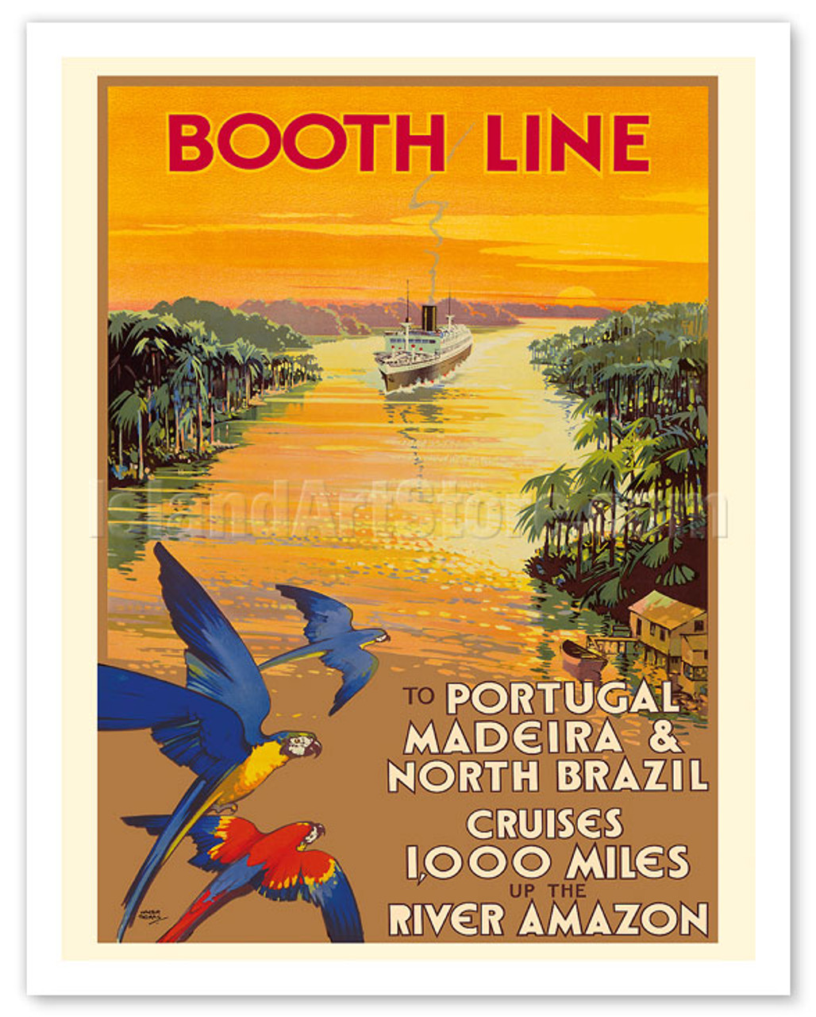

**Annual Scottish Maritime History Conference**

**21-22 October 2025**

**21 October Evening Lecture**

Yudowitz Seminar Room 1, Wolfson Medical School,

University of Glasgow, University Avenue

**5.30 - 7.30 Dr Robb Robinson, University of Hull**

*Virtual Viola: electronically salvaging the career of the world’s oldest steam trawler*

**22 October Conference Programme**

Moir Dyer Room, Mitchell Library, North Street, Glasgow

**10.25 Introductory remarks, Dr Martin Bellamy, Glasgow Life Museums**

**10.30 Session 1, Chair: Professor Faye Hammill, University of Glasgow**

**Elizabeth Allen, The Tall Ship**

*The Amazon, the Booth Line, a Scottish romance and a tourist ‘Boom’*

**Dr Lloyd Belton, University of Glasgow**

*‘To Trade Freely with All’: Mediating the Kru Labour Crisis in Early Colonial West Africa*

**11.30 Tea/Coffee**

**12.00 Session 2, Chair: Professor Niall McKenzie, Strathclyde Business School**

**Dr David Morgan-Owen, University of St Andrews**

*Shipping and the state in First World War Britain: between the national and the global*

**Dr Roy Fenton, British Commission for Maritime History**

*Coaling the Grand Fleet at Scapa Flow: A Nightmare for Jellicoe and Grangemouth*

**1.00 Sandwich Lunch**

**2.00 Session 3 Chair: Professor Andrew Perchard, University of Otago**

**Dr Catherine Scheybeler, King’s College London**

*A Chief Surveyor’s Inspection of Scottish Iron Shipbuilding, 1847*

**Dr Nina Baker, Independent engineering historian**

*‘Human spiders spin and spin’: The Scottish ropemaking industry in transition from the age of sail to the age of steam*

**3.00 Tea/Coffee**

**3.30 Session 4, Chair: Professor Alan McKinlay, Newcastle Business School**

**Michael Leek**

*The Battle of Trafalgar, Interpretations through Art; 220 years on*

**Professor Bruce Peter, Glasgow School of Art**

*Ferry Chartering: A Stena Concept, 1965-2025*

**4.35 Closing Remarks, Professor Hugh Murphy, University of Glasgow, National Maritime Museum, Greenwich**

*This conference is kindly sponsored by the British Commission for Maritime History, Glasgow Life, Lloyd’s Register Foundation, The Lind Foundation and the Society for Nautical Research.*



**The Lind Foundation The Society for Nautical Research**

**Annual Scottish Maritime History Conference Abstracts**

**Elizabeth Allen, The Tall Ship**

**The Amazon, the Booth Line, a Scottish romance and a tourist ‘Boom’**

This paper looks at opening of the Amazon to international shipping and the role of the Liverpool-based Booth Line in it. It will highlight a ‘Scottish romance’ between a merchant naval war hero and a leading lady botanist on the passenger liner Hilary of 7,420 g.r.t. the largest ship in the Booth Line fleet, completed in August 1931 by Cammell Laird & Co. Ltd., Birkenhead for the Liverpool to Manaus route, and leads to open questions about the use of pleasure cruising to engender a tourist boom.

**Dr Lloyd Belton, University of Glasgow**

**‘To Trade Freely with All’: Mediating the Kru Labour Crisis in Early Colonial West Africa’**

This paper examines the intensifying inter-imperial competition for Kru labour—both maritime and terrestrial—in West Africa in the mid- to late-nineteenth century, a period marked by the transition from informal imperialism to formal colonial rule on the continent. It foregrounds the tension between market liberalisation and protectionism and traces its impact on the economic, social, and political networks of the Kru, a coastal West African people whose collective identity and livelihoods had long been shaped by engagement in both licit and illicit Atlantic maritime commerce. For generations, Kru hiring aboard European and American vessels operated through unregulated wages, informal contracts, and convoluted chains of brokerage involving krogba tribal leaders, headmen, and European agents. However, the second half of the nineteenth century witnessed new imperial attempts to curtail out-migration and institutionalise labour recruitment, driven by the imperative to retain scarce manpower in newly established colonies. British, French, and Spanish governments, shipping lines, and colonial administrators sought to resolve what became known as the “Kru labour crisis” by implementing regulatory frameworks and contractual regimes. British shipping lines such as the Liverpool-based Elder Dempster, which relied heavily on Kru seafarers, spearheaded efforts to establish a “Kru Shipping Conference” that would allocate labour quotas among European powers. Confronted with this encroachment on their traditionally itinerant modes of life, Kru workers pushed back and mobilised Enlightenment-era ideals—particularly the right to free movement—to assert their autonomy and defend their longstanding claim to “trade freely with all.”

**Dr Lloyd Belton** is a British Academy Postdoctoral Fellow in the School of Humanities, University of Glasgow. He is a historian of the eighteenth and nineteenth-century Atlantic world and focuses on slavery, carcerality, abolitionism and empire.

**Dr David Morgan-Owen, University of St Andrews**

**Shipping and the state in First World War Britain: between the national and the global**

The relationship between shipping and the state during the First World War has overwhelmingly been shaped by ideas of ‘control’ and ‘nationalisation’. In this telling shipping was like many other areas of economic life; it required state intervention to rationalize its commercial practices in the pursuit of wartime organization. That intervention arrived in late-1916 with the creation of the Ministry of Shipping, which succeeded in ‘controlling’ the use of maritime transport. This paper develops an alternative account of the wartime relationship between ships, shipowners, and the state. Ships and the trade they carried were a tangible manifestation of a reality known to all historians; that Britain was a primary driver and beneficiary of globalization before 1914. The advent of war did not change this basic reality. As a result, the emphasis placed upon ‘national’ organization is fundamentally antithetical to how Britain made war between 1914-18. British strategy was predicated upon its capacity to exploit, adjust, and re-make the forms of global connectivity that had underpinned its financial and geopolitical power before 1914. This could not be achieved through any measure of state control possible between 1914-18. The state lacked the economic understanding, administrative capacity, or political appetite to dictate world trade. Rather, the state evolved a purposeful policy of partnership and co-operation with maritime business that saw the logic of shipping become central to British strategic decision-making. The dictates of maritime transport ‘controlled’ how the war was fought and ensured that it was far more than a ‘national’ endeavour.

**Dr David Morgan-Owen** is a senior lecturer in the Department of International Relations at the University of St Andrews. His research examines British strategy-making and strategic thought in the nineteenth and twentieth centuries. David’s first book The Fear of Invasion: Strategy, Politics, and British War Planning, 1880-1914 (Oxford, 2017) won the Templer Medal for best first book from the Society for Army Historical Research in 2017. He has held fellowships at the National Museum of the Royal Navy and the National Maritime Museum and was the recipient of the Julian Corbett Prize in Modern Naval History in 2016.

**Dr Roy Fenton, British Commission for Maritime History**

**Coaling the Grand Fleet at Scapa Flow: A Nightmare for Jellicoe and Grangemouth**

Fuelling the Grand Fleet in its remote First World War anchorage of Scapa Flow required an enormous transportation effort. The burden fell equally on the rail network, which transported coal from the Rhonda Valley, the huge fleet of war requisitioned colliers, and the port of Grangemouth, which was closed to all commercial traffic for the duration. Railway historians have extensively covered the burden on the rail network, but the demands placed upon shipping and the port of Grangemouth have received almost no coverage. Indeed, preliminary inspection of histories of the port of Grangemouth reveal a lacuna for the period 1914-1919, despite the huge amount of coal its docks handled. Although there are extensive records of individual colliers requisitioned during the war, specific details of their actual service are lacking. This paper intends to shed more light on these operations and answer a number of questions: Why was Grangemouth chosen as the dispatch port? Why wasn’t steam coal shipped directly from South Wales ports? What was the effect of closing Grangemouth to all but military traffic? Consideration is given to estimation of numbers of colliers employed between Grangemouth and Scapa Flow, and losses suffered, and the hardships of merchant navy and Royal Navy crews during operations, especially coaling at sea.

**Dr Roy Fenton** is an independent researcher, author and publisher, who specialises in cargo ships of the steam and diesel era and those who built and operated them. He is a trustee of the British Commission for Maritime History, and a director and trustee of the World Ship Society. His latest monograph is Evolution and Significance of the Powered Bulk Carrier: The Black Freighters, Research in Maritime History No. 56, (Liverpool University Press, 2023).

**Dr Catherine Scheybeler, King’s College London**

**A Chief Surveyor’s Inspection of Scottish Iron Shipbuilding, 1847**

As Principal Surveyor of Lloyd’s Register of Shipping, Augustin Francis Bullock Creuze (1800–52) was instructed in 1847 to carry out a routine visitation tour of Scottish shipyards. Creuze suggested that this presented a potentially valuable opportunity for studying the then still novel but rapidly expanding methods of iron ship construction at a location which was at the centre of iron and steam-powered ship technological development. Creuze’s interest in iron shipbuilding dated back to when he was working for the Royal Navy at Portsmouth Dockyard where, in 1840, he surveyed the Nemesis, the first ocean-going iron-hulled British warship. Following his employment by Lloyd’s Register of Shipping in 1844, it was an interest, and expertise, which he continued to develop, especially as this Society sought to ensure that its classification requirements were up to date and fully adapted to ensure the greatest possible level of safety at sea without unnecessarily inhibiting technological creativity and progress. His subsequent report, which included visits to, among others, the shipbuilders Robert Napier &amp; Sons, Denny Brothers, John Scott &amp; Sons, and Caird &amp; Co., reflects these concerns, provides a valuable insight into the state of iron shipbuilding on the River Clyde at this time and highlights the challenges generated by technological transition. This paper will explore these themes as it describes Creuze’s 1847 tour of Scottish shipyards.

**Dr Catherine Scheybeler** is a historian and Lecturer in Defence Studies at King’s College London. She specialises in the eighteenth-century Spanish navy and is a member of the Editorial Board of the world’s oldest international quarterly journal of maritime history, The Mariner’s Mirror, and the Council of the Society for Nautical Research and is also Chair of its Maritime Heritage Committee. She is currently a consultant for Lloyd’s Register Foundation’s Heritage and Education Centre.

**Dr Nina Baker, Independent engineering historian**

**‘Human spiders spin and spin’: The Scottish ropemaking industry in transition from the age of sail to the age of steam**

“Knowing the ropes” is one of the many phrases that have come to us today from the days when sailing ships were the principle means of both local and international travel. The deckhand had to know where every rope, large or small, was and what he needed to do with it in any circumstance. It was a hard life at sea and almost exclusively male and until the mechanisation of the process and the industry’s transition to water and steam power, ropemaking too was almost exclusively male. However, during the transition to steam in the workshops and long before the transition to steam at sea, increasingly women replaced men in the ropeworks. They too had a hard life and were generally from the same working class as the deckhands. They were doing work that was essential to nation in both peace and war. A ship of 1250 tons DWT (HMS Victory is 2162 tons DWT) would require over 18 miles of cordage of a myriad of sizes from ½ inch up to 16 inches diameter, plus a lot of smaller twines and cords for canvas sewing or whipping ropes’ ends. There were hundreds of ropeworks, large and small, making cordage for all manner of uses (not just for ships) in all manner of sizes. This talk will look at the spread, rise and decline of the ropemakers in Scotland and will include descriptions of the changing technologies and materials and recollections from some workers in the 20th century.

**Dr Nina Baker** is a former merchant navy deck officer who later became a materials engineer and then a politician. She is now a historian specialising in the history of women in the history of UK engineering and construction trades and professions.

**Michael Leek, MA, MPhil (RCA), Cert Ed, FRSA, AFRHistS.**

**The Battle of Trafalgar, Interpretations through Art; 220 years on**

The use of contemporary or more recent marine drawings and paintings to illustrate histories of wars and specific naval battles is accepted practice, and rightly so - they add context, besides which a picture is worth a thousand words! However, contrary to received opinions by many historians, these artworks, regardless of how well executed, are rarely, if ever, 100% accurate. This is evidenced by making analytical examinations between paintings by different artists, over different periods of time, of the same action, using empirical evidence from log books and ships plans, etc, to establish weather and light conditions, and obviously much more. It is my contention that each piece of artwork is very much the interpretation of the individual artist to the point that each work becomes an impression - contrary to the labels applied to art by such theoretical art historians from the likes of the Courtauld Institute! Only since the introduction of photography are we able to get a reasonably accurate visual record of an action, albeit with inevitable limitations. Even having artists present at an action - such as the van de Veldes in the seventeenth century - does not guarantee a complete and accurate record. This brief talk is a mere introduction to what is a complex subject, one that is currently being explored in greater depth.

**Michael Leek** trained as a technical and information illustrator. He was Head of the School of Illustration at the Arts University Bournemouth, where he researched, designed and directed visual information heritage projects in Britain, Sweden and Aland; notably on HMS Victory, SS Great Britain, HMS Warrior, Cutty Sark, HMS Gannet, Portwey, HMS Belfast, Pommern and Vasa - the last two in collaboration with Malardalen University. he has written and contributed to a number of books, including *The Art of Nautical Illustration* (London 1991) and has exhibited with the Royal Society of Marine Artists.

**Professor Bruce Peter, Glasgow School of Art**

***Ferry Chartering: A Stena Concept, 1965-2025***

The recent entry into service of the new hybrid electric/LNG-powered Saint-Malo and Guillaume de Normandie, operated by Brittany Ferries under long-term charter from Stena RoRo, reflects a growing phenomenon of asset-light operation in transport, evident also in the road and air transport sectors. This presentation examines the transfer of the application of chartering from bulk shipping to the ferry sector from the mid-1960s onwards. It will be shown why the Swedish Stena AB line became the innovator, subsequently joined in the 1970s by other Swedish companies who benefitted from shipbuilding subsidies and a taxation regime encouraging investment in ships to build excess ferry tonnage. These companies initially supplied nationalised short-sea operators in the UK and Canada with up-to-date vessels. The early lead gained by the Swedes – and the expertise in ferry design that was accumulated – continues to reap benefits with ‘sustainability’ nowadays an important criterion for success. Against a rapidly evolving legislative context, chartering is also a low-risk and cost-effective solution for operators.

**Bruce Peter** is Professor of Design History at The Glasgow School of Art. He has written extensively about modern design and architecture in the contexts of travel and leisure. He is the author of several books and has appeared in various television documentaries. His latest monograph is Art Deco Scotland: Design and Architecture in the Jazz Age, (Edinburgh, 2025). He has regularly contributed journalistic writing to shipping industry publications produced by Shippax in Halmstad, reporting on the development of the international ferry industry