Naval Dockyards Society 31st Annual (hybrid) Conference
Supplying and maintaining the Indo-Pacific Fleets in the Second World War
National Maritime Museum Greenwich Saturday 20 March 2027
Call for Papers
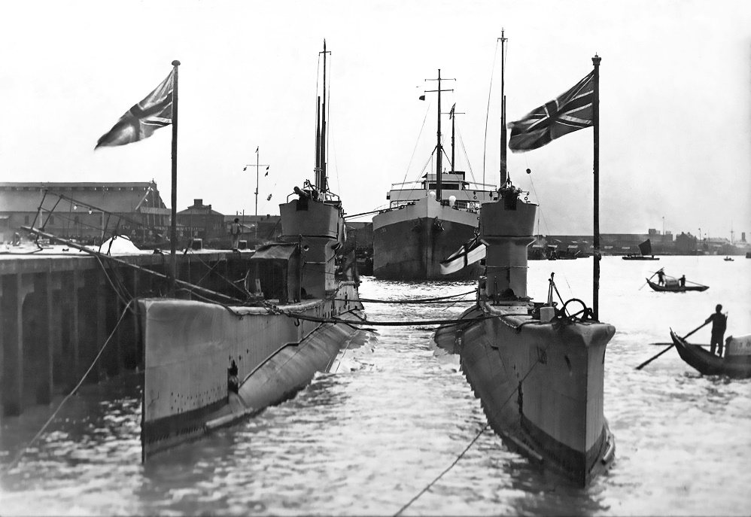 | 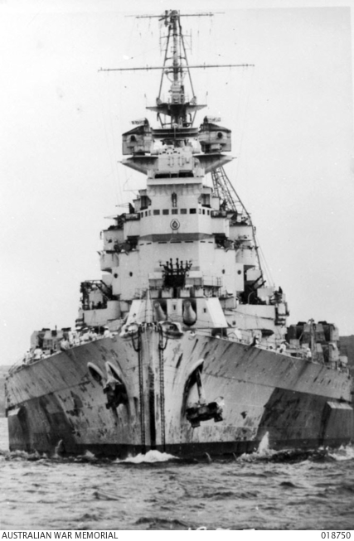
Left Submarines L1 and L20 alongside in Shanghai, we believe, in 1925 or 1926, a photograph taken by Reuben Milstead, Telegraphist in L1, with permission of the Submariners Association https://www.submarinersassociation.com/. The ship lying astern is the Norwegian tanker Liss, built on Teesside in 1921 by Furness Shipbuilding, which sailed under Nortraship management in WW2. (https://skipshistorie.net/Oslo/OSL386AHMathiesen/Tekster/OSL38619210100000%20LISS.htm).
Right HMS King George V steaming up Sydney Harbour, 1945. Australian War Memorial, Accession No. 018750. Public domain (https://www.awm.gov.au/).
The NDS identifies July 1937 as the beginning of the Asia-Pacific War, December 1941 extending the Sino-Japanese war into a wider Indo-Pacific Ocean war involving Britain, the United States, Australia, the Netherlands and Norway, and critically embedding Royal Navy dockyards and logistical infrastructure. This interpretation challenges the narrative of the Pacific War as a solely American operation and emphasises British and Australian logistical transformation of base infrastructure around Sydney.
This conference highlights the indispensable contribution of merchant navies and their sailors and the global shore-based infrastructure to the Allied victory. All proposals relevant to the Conference theme will be considered, particularly including the following.
Conference proposals could address:
- Evaluating the status of Singapore, Hong Kong, Trincomalee, Bombay, Colombo and other Indo-Pacific bases in 1937–41
- How the Sino-Japanese war 1937–41 affected British naval planning and logistics
- How the Royal Navy’s China Station was destabilised, 1937-42
- How Singapore Dockyard prepared for the possibility of Japanese war
- Appraising the scale and challenges of supplying ammunition, fuel, repair facilities and personnel to the Indo-Pacific Fleets in the Second World War
- Evaluating the effect of the collapse of Hong Kong and Singapore on the Indian Ocean infrastructure
- Assessing the effectiveness of Colombo, Trincomalee, Bombay and Simon’s Town in sustaining the Eastern Fleet following the collapse of Hong Kong and Singapore
- Assessing Dutch naval involvement, surface and submarine, at Colombo, Fremantle and Sydney
- Evaluating the role of international merchant navies and their sailors, such as those of the Netherlands and Norway
- How the Royal Navy was transformed from a fleet supported by imperial bases in Singapore, Hong Kong and Ceylon into a fleet operating against Japan sustained from Australia
- Appraising the WW2 transformation of Sydney Harbour’s infrastructure and the role of Mobile Naval Air Bases (MONABs)
Dockyard Chronology
1937–39 China Station/Hong Kong/Singapore
Japan’s war against China creates an increasingly dangerous East Asian environment.
1940–41 Singapore becomes the great British strategic focus
The dockyard and naval base expand in anticipation of war with Japan.
7 December 1941 Japan attacks Pearl Harbour naval station and shipyard, followed by attacks on British, Dutch and Australian territories
Transforms the Sino-Japanese War into a multinational war involving the United States and the British Empire.
December 1941–February 1942 Singapore falls
Britain loses its great forward base.
April–May 1942 Ceylon is threatened
Eastern Fleet withdraws west.
1942 Kilindini becomes the emergency western base
Mombasa, in Kilindini Harbour in Kenya, supports the Eastern Fleet, East African communications, and Madagascar operations.
1943–44 Trincomalee is rebuilt/reopened as the principal Eastern Fleet base
The fleet gradually moves east again. Australian destroyers, for example, operate with the Eastern Fleet from Trincomalee in 1944.
Late 1944 British Pacific Fleet is created
Admiral Sir Bruce Fraser becomes Commander-in-Chief. Churchill informs Australian Prime Minister John Curtin in November 1944 that the fleet would be sent to the Pacific and maintained in Australia.
1945 Sydney/Australia becomes the logistical base for Britain’s war against Japan
The Royal Navy is now operating from Australia 4,000+ miles from Japan and roughly 16,000 miles from Britain’s supply sources, making the Fleet Train (Task Force 112) and Australian infrastructure critical.

If your proposal is accepted, you will present in-person or online. We shall refund UK/European travel fares to the conference (or travel from a UK airport to Greenwich), your fee, lunch, and contribute to accommodation, publish your paper in NDS Transactions (https://navaldockyards.org/transactions/) and give you a copy. Your talk will be c.35 minutes, the printed paper 6–10k words, due 31 June 2027.
Send your title, a 300-word synopsis and a 100-word biography by 16 October 2026 or earlier to Roger Bendall roger@rogerbendall.com and Dr Ann Coats avcoatsndschair@gmail.com N.B. The proposal should present original research.
https://navaldockyards.org/conferences/ https://navaldockyards.org/ Facebook: NavalDockyardsSocietyhttps://www.facebook.com/groups/1443502952760615

