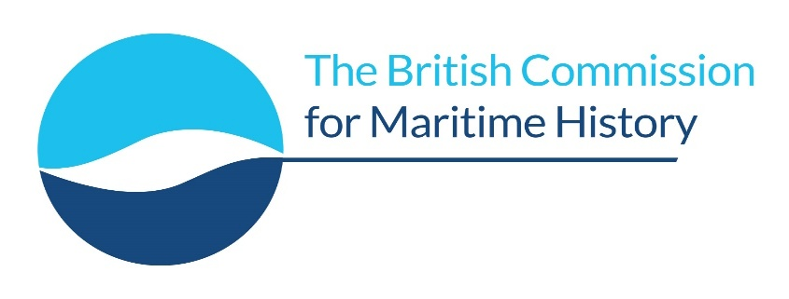

New Researchers in Maritime History Conference 2027

National Maritime Museum, Royal Museums Greenwich

14/15 May 2027

Call for Papers

The British Commission for Maritime History (BCMH), in association with the National Maritime Museum in Greenwich, invites contributions to its thirty-second conference for new researchers. The National Maritime Museum as part of Royal Museums Greenwich provides an ideal setting with its focus on different aspects of maritime heritage. The Museum is at the heart of Greenwich's UNESCO World Heritage Site. It is a delightful setting for this annual conference and provides a unique opportunity for new scholars to present their work in a historic setting.

The conference, which is supported by the Society for Nautical Research and Lloyd’s Register Foundation helps emerging scholars who wish to share their work in a supportive environment and build relations with other maritime historians. We encourage applications from postgraduate students and warmly encourage participation by independent scholars. Contributions can address all aspects of maritime history in its broadest sense.

Those wishing to offer a paper should complete the online form available from
https://forms.gle/DTghTm4dniTYSWqm8

or from the BCMH website www.maritimehistory.org.uk

Please direct any queries to newresearchers@maritimehistory.org.uk

Paper deadline 5 February 2027

Anyone interested in attending the conference without presenting a paper is also warmly invited to register an interest; further information will be sent to you in due course.

